DTSC 671: AI Solutions in the Cloud

Text Extraction with Amazon Textract

Goal
Your organization wants a cloud solution to automatically extract key information from resumes submitted by job applicants. Once users upload their resume PDFs, the organization wants to use document intelligence to identify important fields such as the applicant’s name, email address, and skills.

In this assignment, you will upload a resume PDF to an S3 bucket, which will trigger a Lambda function. The Lambda function will call the Amazon Textract API to perform text extraction on the document, parse the information, then store a CSV file with the extracted fields in a separate S3 bucket.

You will submit the template with the requested screenshots on Brightspace. Please note you only have one submission attempt.

Architectural Overview



S3 upload triggers Lambda function which uses Textract to analyze PDF, parse information, and store information in CSV
Lambda saves CSV file in output S3 bucket
Upload PDF file to S3 bucket
User uploads resume PDF, which is sent to S3 bucket
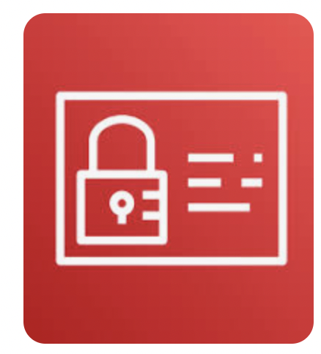
IAM role gives Lambda the permissions to retrieve and store files in S3 and call Textract


Pricing Estimate
IAM role enables Lambda to create CloudWatch log to track activity and call the Textract API
The following estimate shows the costs you may incur on your AWS personal account.

AWS Pricing Estimate
Service | Calculation | Cost
S3 Standard Storage | You will store a PDF file in one bucket and have a CSV file as output in another bucket.  These will be very small fill sizes. Suppose the PDF is 50 KB and the CSV is 10 KB.  S3 Standard pricing is roughly $0.023 per GB per month (varies slightly by region).  60 KB = 0.000006 GB  0.000006 GB x ($0.023) = $0.000000138 | < $0.01
Lambda | Lambda assumption:  - Memory allocated: 256 MB  - Execution time: 2460 ms (billed + initial)  - Requests: 1  - GB-seconds: (128 MB ÷ 1024) × 2.460 sec = 0.3075 GB-sec  Lambda pricing:  - Free tier: 1M requests & 400,000 GB-seconds/month  Cost Calculation (if beyond free tier)  - Cost: 0.3075 GB-second × $0.00001667 = $0.000005126 | Free tier
Textract use in Lambda function | Textract  - $0.015 per page analyzed (first 100 pages free for first three months) | Free tier

Directions
Make sure that all your services are in the same region (e.g., us-east-1)
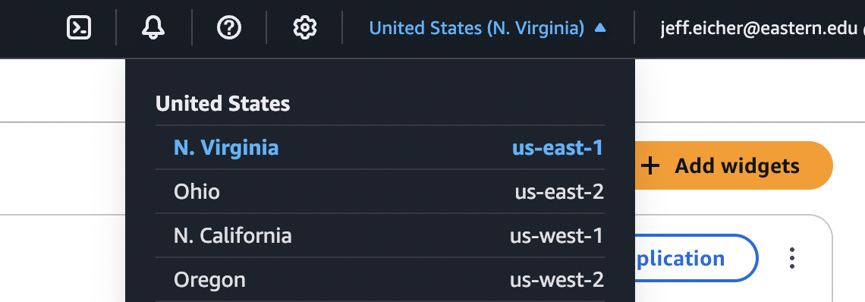

STEP 1: Download the resume PDF on Brightspace
- Navigate to Brightspace and download resume.pdf in this assignment’s folder.

STEP 2: Create two S3 buckets
- Name one bucket dtsc-671-textract-input-<term>-<year>-<name>
  - For example, dtsc-671-textract-input-fa1-2025-jeffeicher
  - Include tags for cost tracking; such as key: dtsc-671 value: textract
- Name one bucket dtsc-671-textract-output-<term>-<year>-<name>
  - For example, dtsc-671-textract-output-fa1-2025-jeffeicher
  - Include tags for cost tracking; such as key: dtsc-671 value: textract
- Note: We are not loading anything in the S3 buckets at this point in the assignment

How do I make an S3 bucket?
Tutorial: How do I make an S3 bucket?

STEP 3: Create, Set Up, Configure, Code Lambda function
- Create a Lambda function with the name: text-extraction-<name>
  - For example, text-extraction-jeffeicher
  - Use Runtime: Python 3.13
  - Create a new role with basic Lambda permissions
  - Include tags with the key-value pair as dtsc-671 and textract, respectively
- Configure the Lambda function.
  - Change the “Timeout” from 3 seconds to 1 minute.
  - Set IAM role permissions: The role must have basic lambda permissions (which includes CloudWatch logging), S3 access to both buckets (s3:GetObject s3:PutObject), and calling the Textract API (textract:AnalyzeDocument).
- Set up the Lambda function.
  - Make the trigger the input bucket you created above.
    - Include a file extension of .pdf as the optional suffix.
  - Make the destination the output bucket you created above.
    - If you get any permissions error, investigate and troubleshoot with Amazon Q.
- Write code for the Lambda function.
  - We want Lambda to take the resume pdf in S3, use the Textract API, parse the extracted fields (Name, Email, Skills), and make a CSV out of it.
    - We encourage you to use an LLM (like ChatGPT, Gemini, etc.) to help you write and debug the code for your Lambda function. It is helpful to give the LLM the resume pdf along with the instructions for the function.
    - Include print statements through your code to help troubleshoot.
  - We want the Name, Email, and Skills output from Textract to be shown in the csv. (See step below for screenshot example output).
  - Make sure that the title of the CSV matches the title of the original PDF file (other than the extension changed from .pdf to .csv)
  - In this assignment, you'll use the Amazon Textract API method analyze_document in your code. Here is the relevant documentation.
  - Make sure that the skills output does not have symbols like | or -.
  - Anytime you make edits to your code, be sure to hit “Deploy”; otherwise, your updated code will not run.
  - Wait until the green banner shows the function has been deployed before moving on.

STEP 4 (Test): Upload the resume PDF to the input bucket
- Once all the previous steps have been completed, upload the resume pdf file in the input S3 bucket.
- Even if you’re not sure your code will work, you can upload the PDF file and see what happens! (Check the CloudWatch log for information.)
- Remember, the skills section should not have symbols like | or -.

STEP 5: Was the Lambda function successful?
There are multiple ways to check if your Lambda function is correct.
- Check your S3 output bucket. Is there a CSV file there? If so, does it look something like the following? (The information will differ)
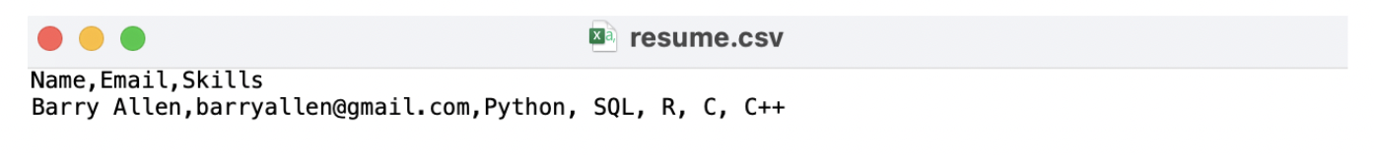
- You can go to the “Monitor” tab in your Lambda function, and select “View CloudWatch logs”.

STEP 6: Troubleshoot

- How do I use CloudWatch logs to troubleshoot my code and architecture?

- Use an LLM to troubleshoot
  - When writing prompts to develop your code, ask the LLM to include error handling to help you diagnose issues with your code or architecture.
  - Give the LLM information such as your Runtime (i.e. Python 3.13) and other configuration details
  - The LLM will likely give you a list of error possibilities. Work carefully through each one. If there’s still an error, let the LLM know what you did to fix any issues.
  - After you have tried troubleshooting with an LLM, if you email the GAs or professor, you must include screenshots of your architecture and error messages.

- Reupload (or overwrite) your JPG to the S3 input bucket. This action will trigger the lambda function to run again. If a JSON with the necessary output is not stored in the S3 output bucket, keep troubleshooting.

- What information does the professor or GA expect in order to assist you?
  - Helping you is much different than classes with CodeGrade—we can’t simply jump into your AWS account and troubleshoot!
  - We expect:
    - Screenshots of your architecture, following each step above, so we can find where the issue may be
    - What prompts you’ve tried with an LLM
    - Error messages in CloudWatch
  - An email that says “my lambda function is not working” is not sufficient and is not helpful
  - Do not post your lambda function code on the discussion boards. All other information and questions can appear there.

STEP 7: Brightspace submission
- Download the assignment template with requested screenshots as a PDF document (File > Download > PDF Document). Submit your template PDF to the Brightspace assignment.

This is course material that was distributed to students enrolled in DTSC 671 at Eastern University. The materials were made exclusively available to students solely for the purpose of completing the course and are not intended for further distribution or retention beyond the course period. The materials were created by program faculty specifically for use in courses at Eastern University.

